Camp Rainbow Le Bourg 63690 – LARODDE, France
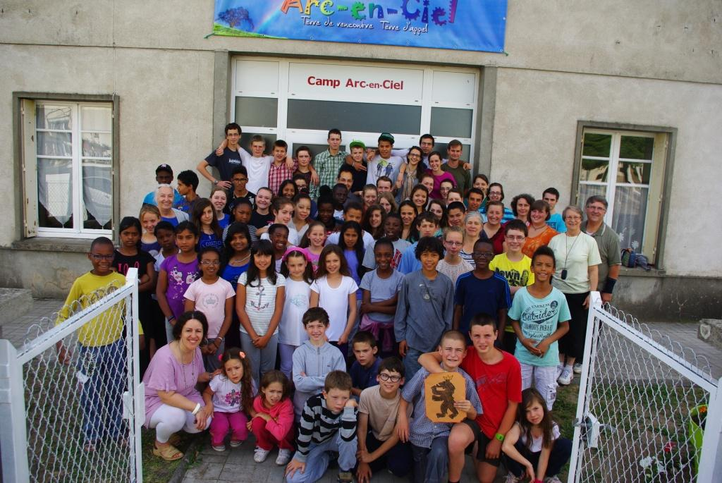
Junior and Teen Camp July 10-24, 2013

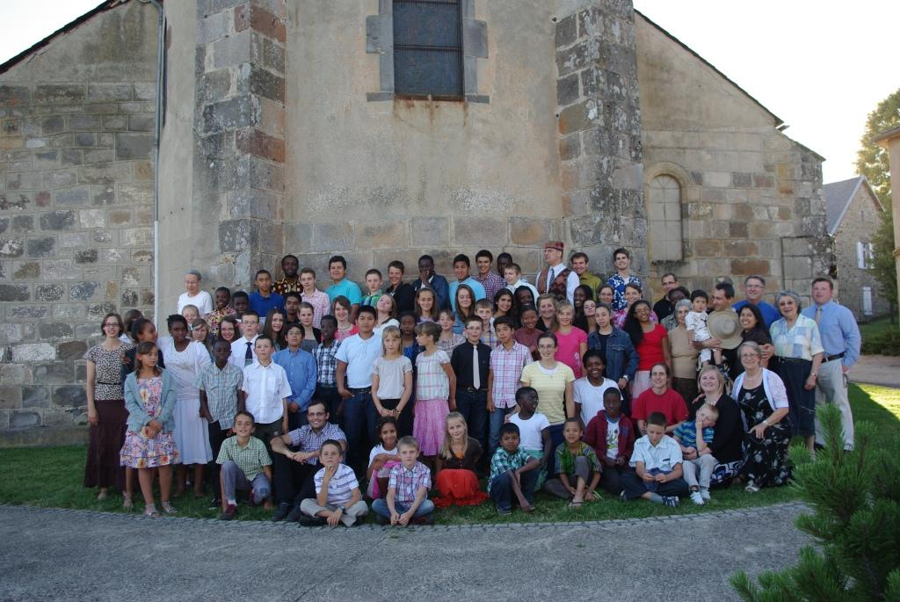
Junior and Teen Camp August 3-17, 2013
Website: camp-arcenciel.fr Tel. 011.33. 473 215 9 42
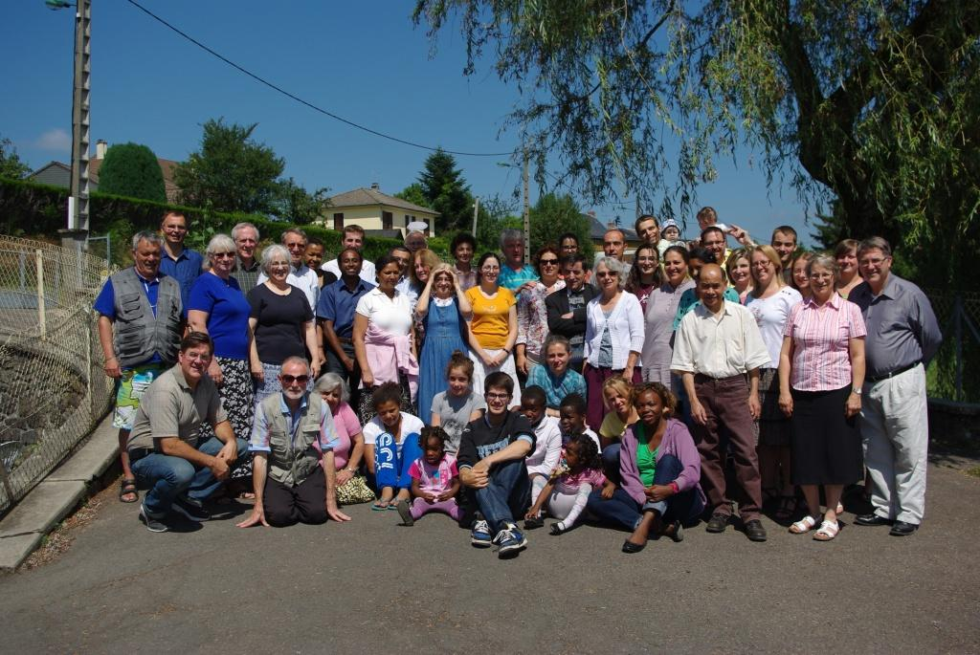
Baptist Alliance Family Camp August 18-24, 2013

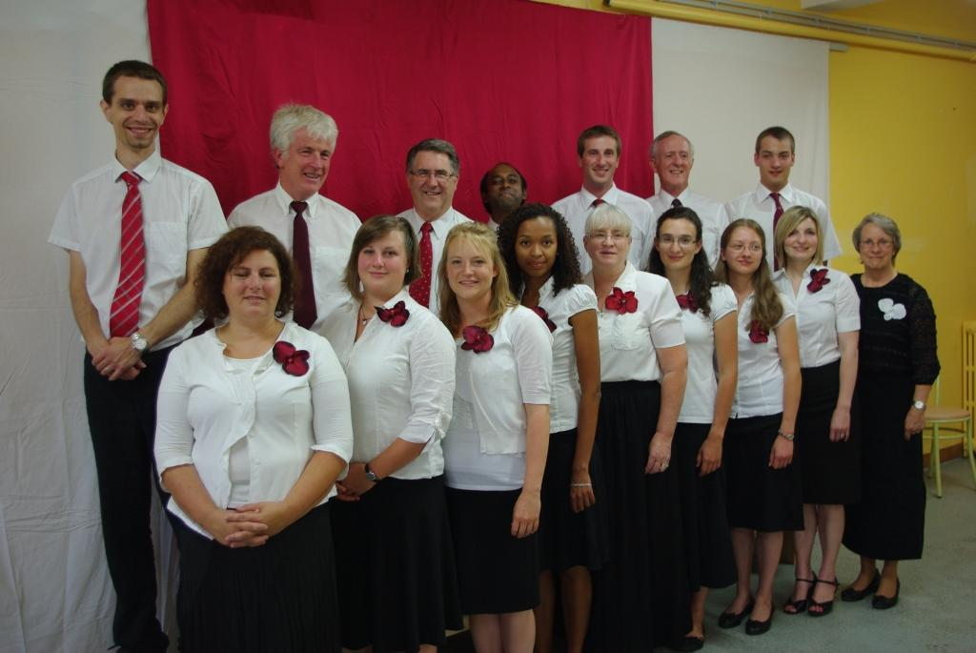
Choir Camp August 17-24, 2013

